{Title of the Project}
- Problem Statement

As the days pass, new technologies have been created to make life easy. In education environment, the teachers face some difficulties to correct some questions like multiple choices and true /false questions. So they have to go through the questions several times to make sure of their correction, as long as they will correct each paper manually. That will take a lot of their time to finish one student paper.

- Project Objectives

New generation creates new things. People nowadays prefer using electronic devices due to the ease of use and time consuming. Electronic Examination Marking (e-marker) will save lecturers effort and time on marking student’s examination sheets.

3. Project Description

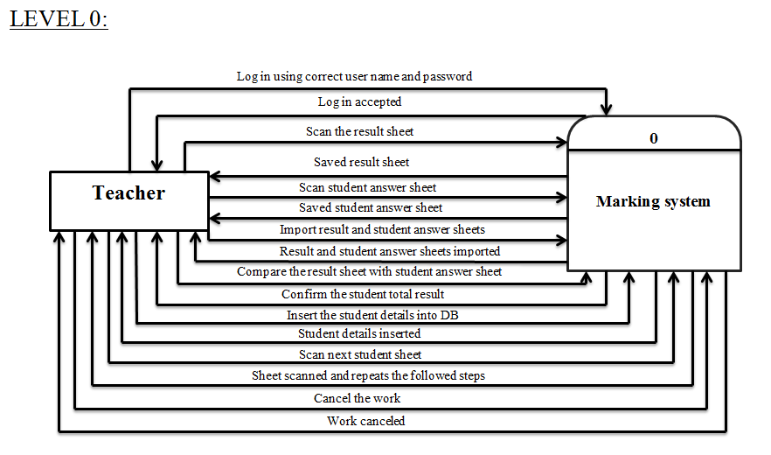
3.1 General Framework

